## 2 PROBLEM DEFINITION AND DESIGN THINKING

2.1 Empathy Map

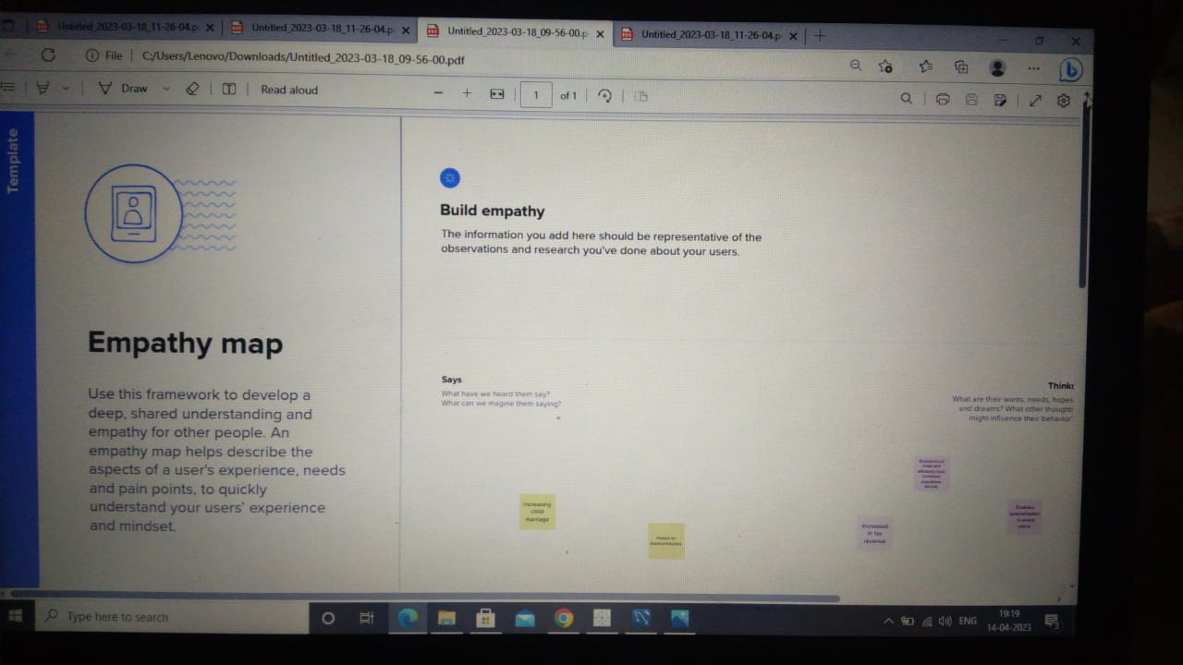

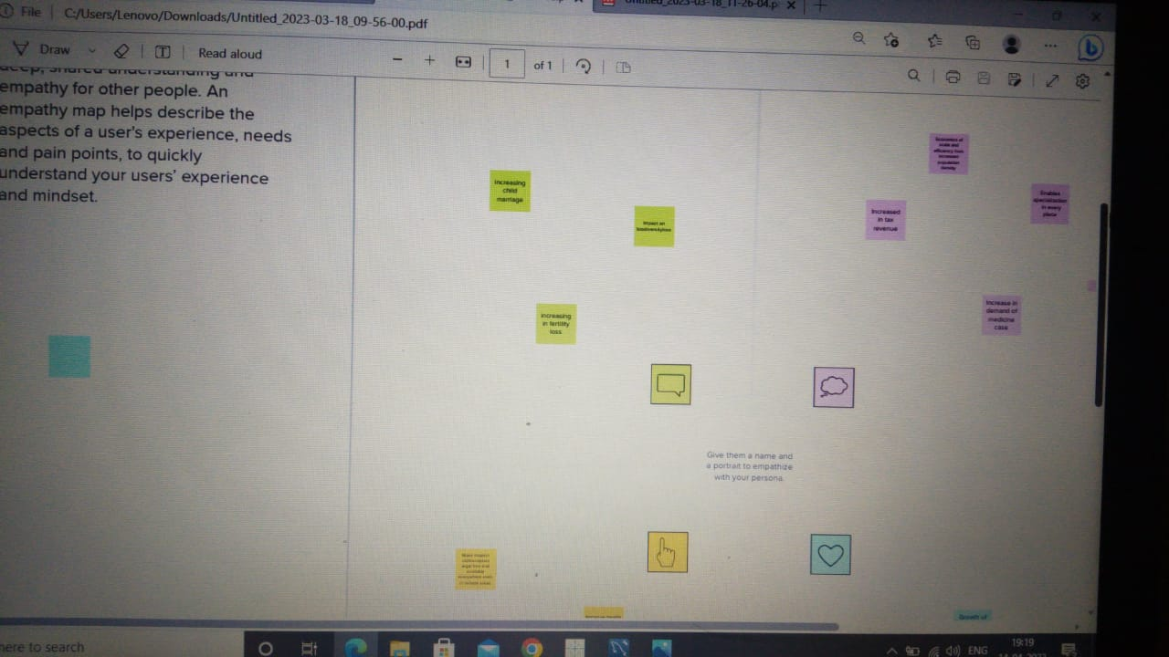

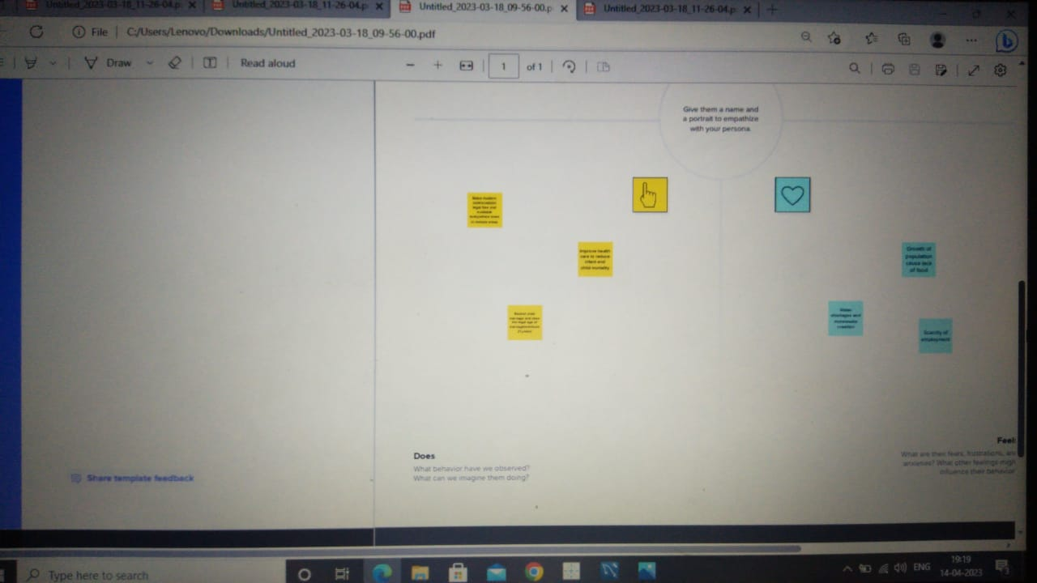

2.2 Ideation and Brainstroming Map

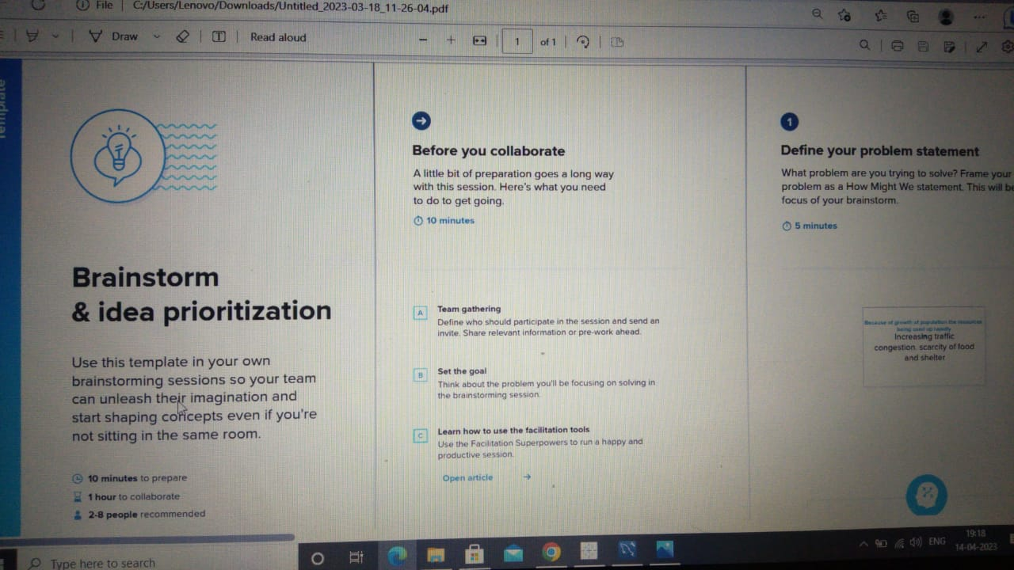

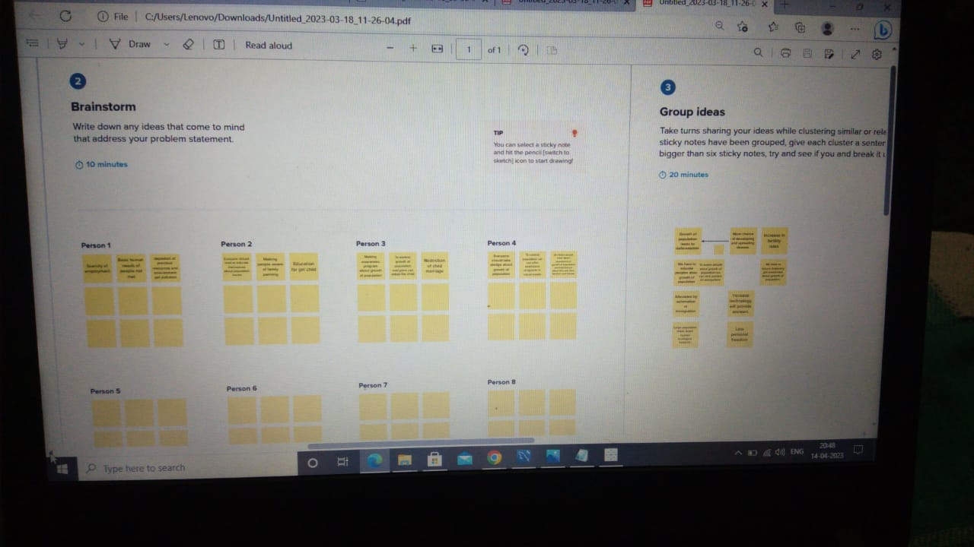

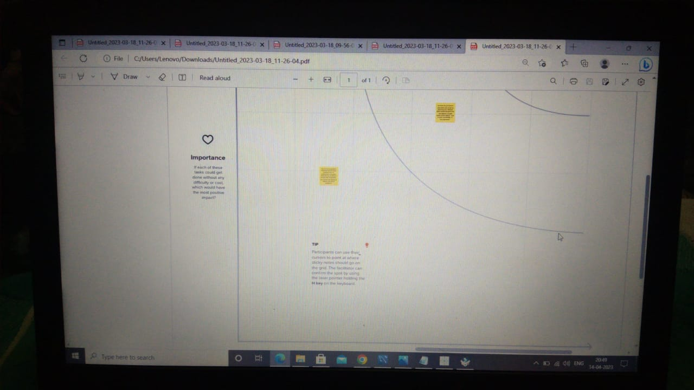

### 3 RESULT

### 

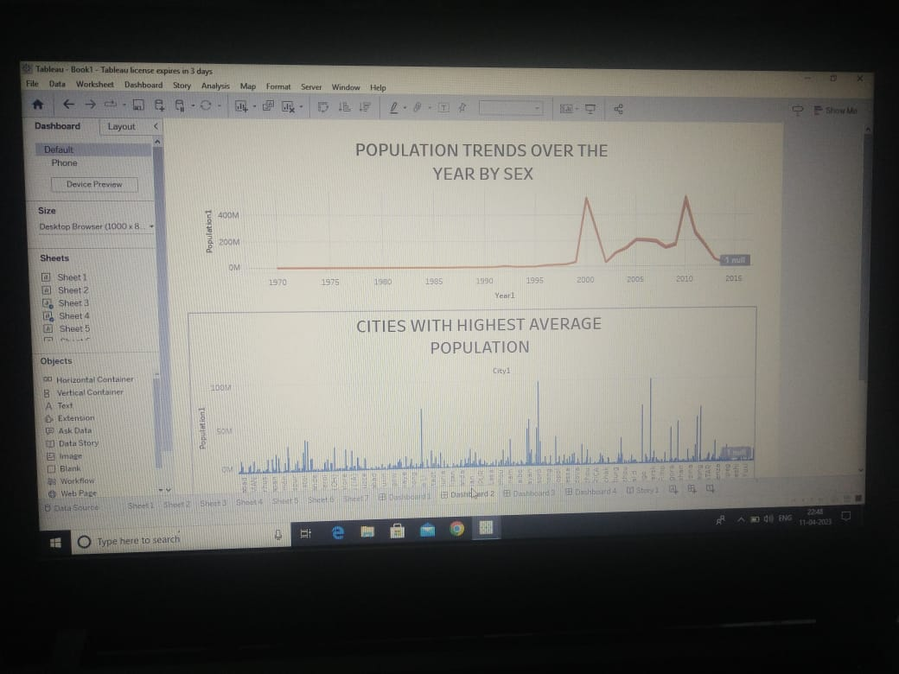

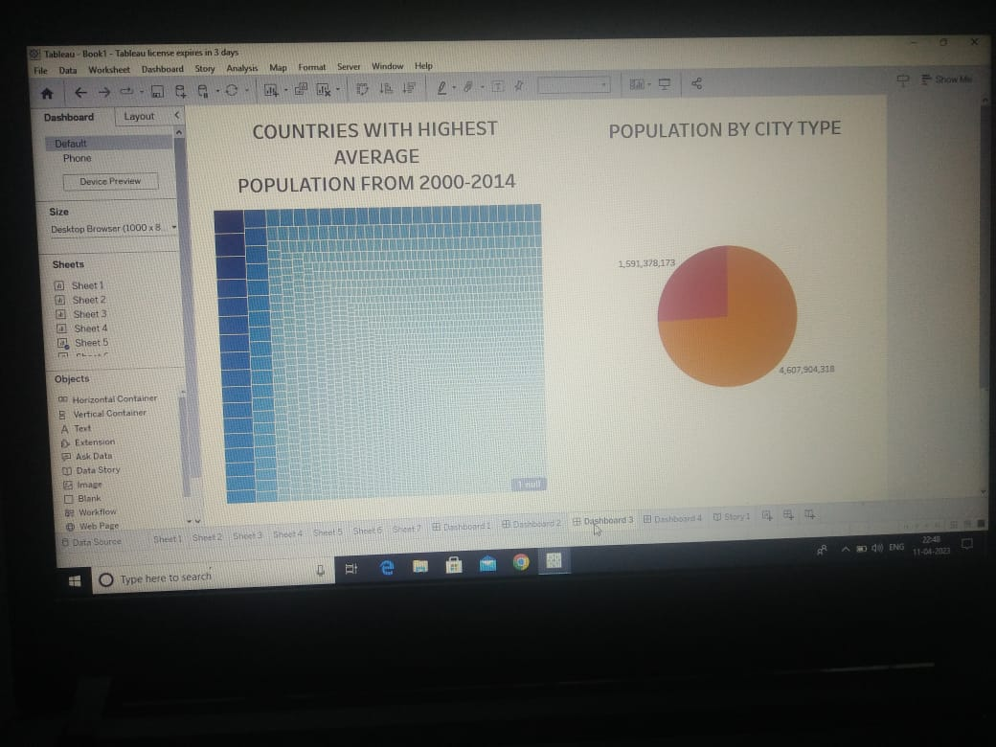

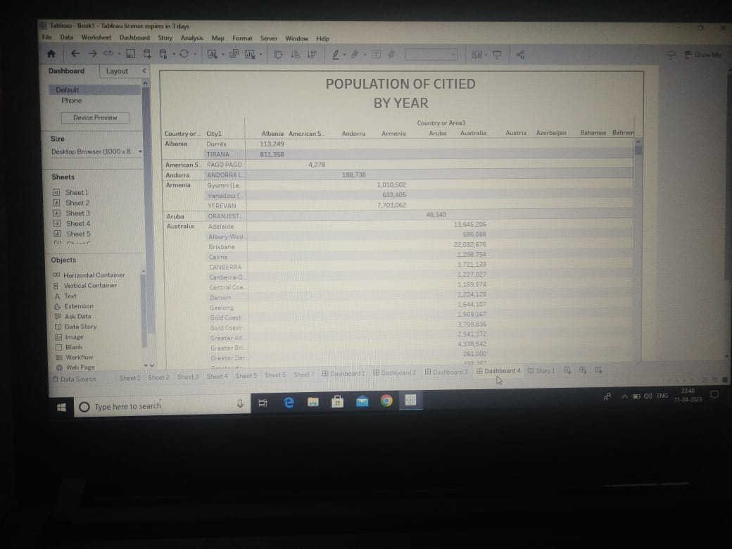

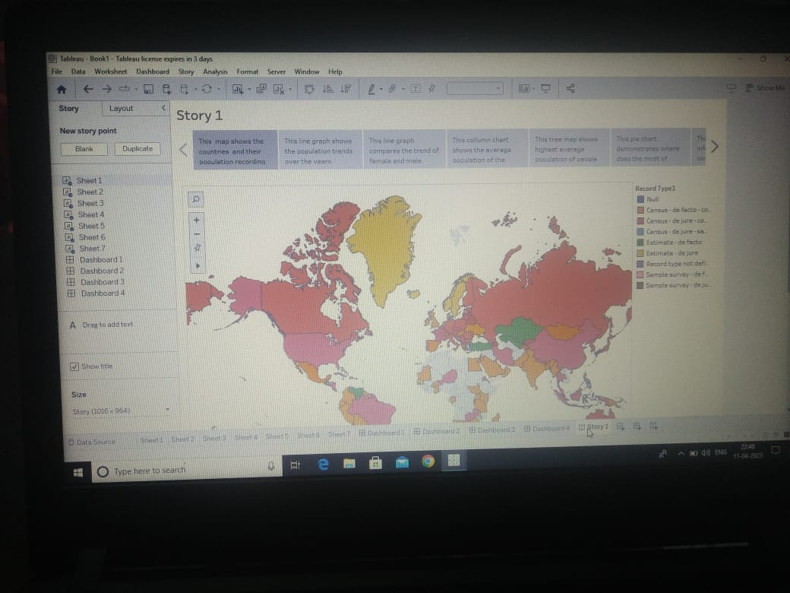

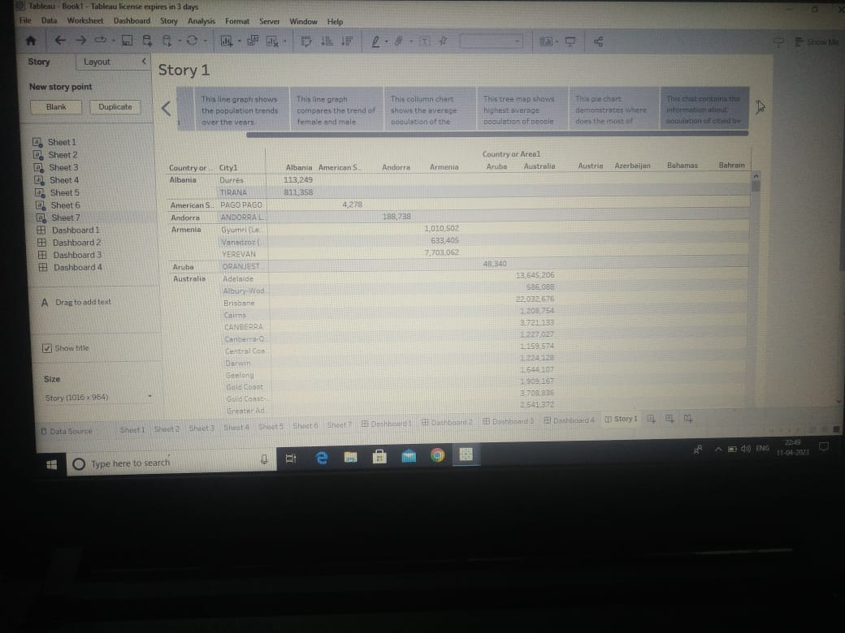

#### 4 ADVANTAGES AND DISADVANTAGES

Advantages;

* The main advantage of our project is peoples to know about the unknown information about the growth of population.
* It gives awareness to everyone.
* By this project we can able to know about future problems and we can make some

prevention for that problem.

Disadvantages;

* We can’t able to solve this problem immediately it take some time to implement and to be solve.
* We does not able to know that everyone have the awareness about growth

of population.

* We have to wait for the result of this problem for the long time.

#### 5. APPLICATION

We have to solve this problem one by one where the solution is applicable. We have to give the solution where the growth of the population is highest. And we have to control it by our solution. We have to aware the people where the population is very high.

#### 6. CONCLUSION

The only solution of this problem is we have make some measures or rules for everyone to control our growth of the population. We have to control growth of population for a good future . we also made people to follow that rules.

#### 7. FUTURE SCOPE

By our project we hope that in future we control the population . My next step in this project again we have to analysis what change was happen by this project among the people and what are the advantages and disadvantage are in our project. How can we overcome the disadvantage of the project. Then what we have to change in our to project to get the solution. After finding the solution we have to execute that in our project and get proper results.